EXP 10
CODE
#include <stdio.h>
#include <sys/ipc.h>
#include <sys/msg.h>
#include <string.h>

struct msg {
long type;
char text[100];
};

int main() {
struct msg m;
int msgid;

// Create message queue
msgid = msgget(IPC_PRIVATE, 0666 | IPC_CREAT);
if (msgid < 0) {
perror("msgget failed");
return 1;
}

// Prepare message
m.type = 1;
printf("Enter message: ");
fgets(m.text, sizeof(m.text), stdin); // safe input

// Send message
msgsnd(msgid, &m, sizeof(m.text), 0);

// Receive message
msgrcv(msgid, &m, sizeof(m.text), 1, 0);

printf("Message received: %s", m.text);

// Delete message queue
msgctl(msgid, IPC_RMID, NULL);

return 0;

OUTPUT:
}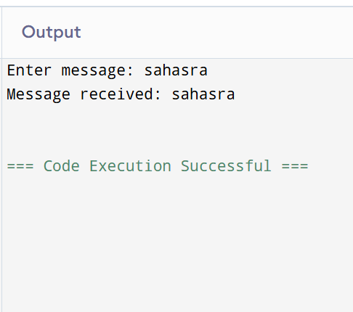
oo

